Chemical equilibrium

* To understand chemical equilibrium we need to understand two things;
* Firstly, we need to understand (remember) that in a reversible reaction, the products can react to produce the original reactants. (That means the reaction can go forward or backward).
* Secondly, we need to understand this two terms; open system and closed system.
  + - If a chemical reaction happens in a container where one or more of the reactants or products can escape, you have an *open system*.
    - If a chemical reaction happens in a container where none of the reactants or products can escape, you have a *closed system*.
* For example, iodine crystals break down to form purple iodine vapour. In an open system, the vapour escapes and the reaction progresses until all of the crystals have vaporised, and all of the vapour has escaped.
* If a stopper is placed on the boiling tube, a closed system is formed. The iodine crystals break down to form purple iodine vapour, but both the crystals and vapour remain.

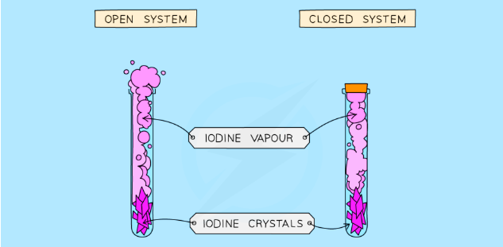

* Many chemical reactions are reversible. In these reactions, there is both a forward reaction (where reactants are made into products) and a reverse reaction (where product molecules break down to form reactants).
* In a reversible reaction, you can never obtain 100 per cent conversion of reactants into products. This is because the products *convert back to reactants*. Therefore, reversible reactions will always result in a mixture of reactants and products being formed.
* You need to note that, as the forward reaction slows down, the reverse reaction will speed up until they are both taking place at the same rate.
* This is called the **chemical equilibrium**.

Characteristic of a reaction at chemical equilibrium

1. Rate of forward reaction is equal to the rate of backward reaction.
2. The concentration of reactants and products remains **constant** (given there is no other change to the system such as temperature and pressure).
3. Equilibrium can only be obtained in a **closed system** where the reaction is carried out in a **sealed container** and none of the reactants or products are lost.